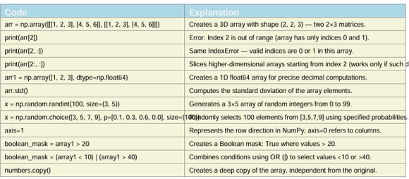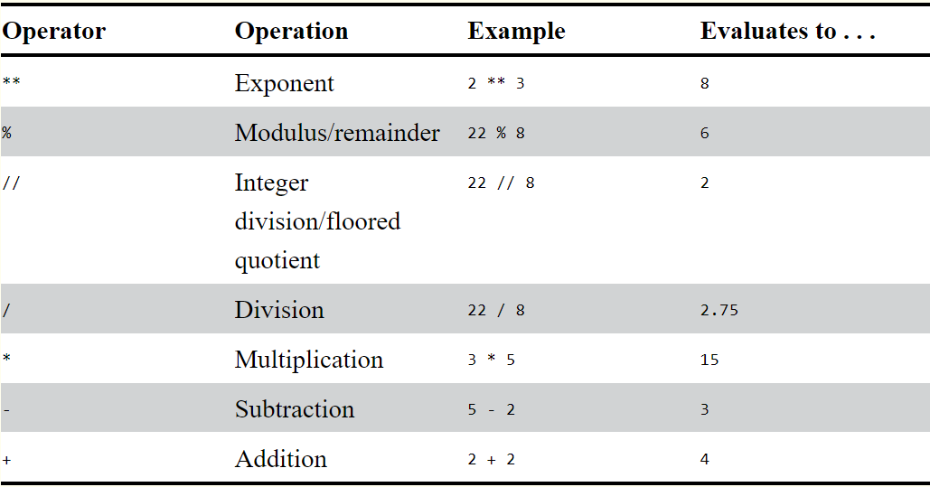
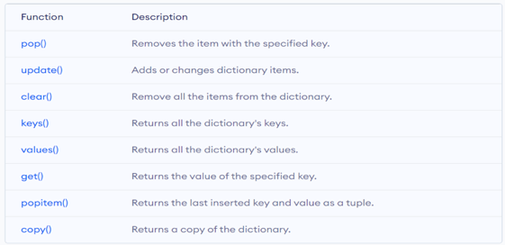
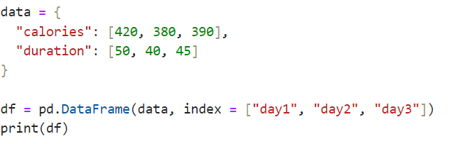
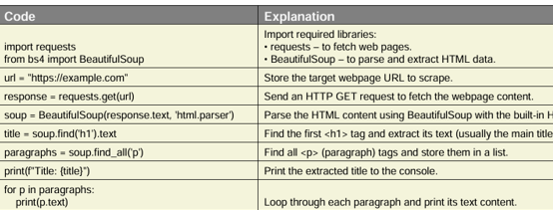
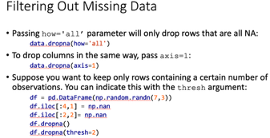
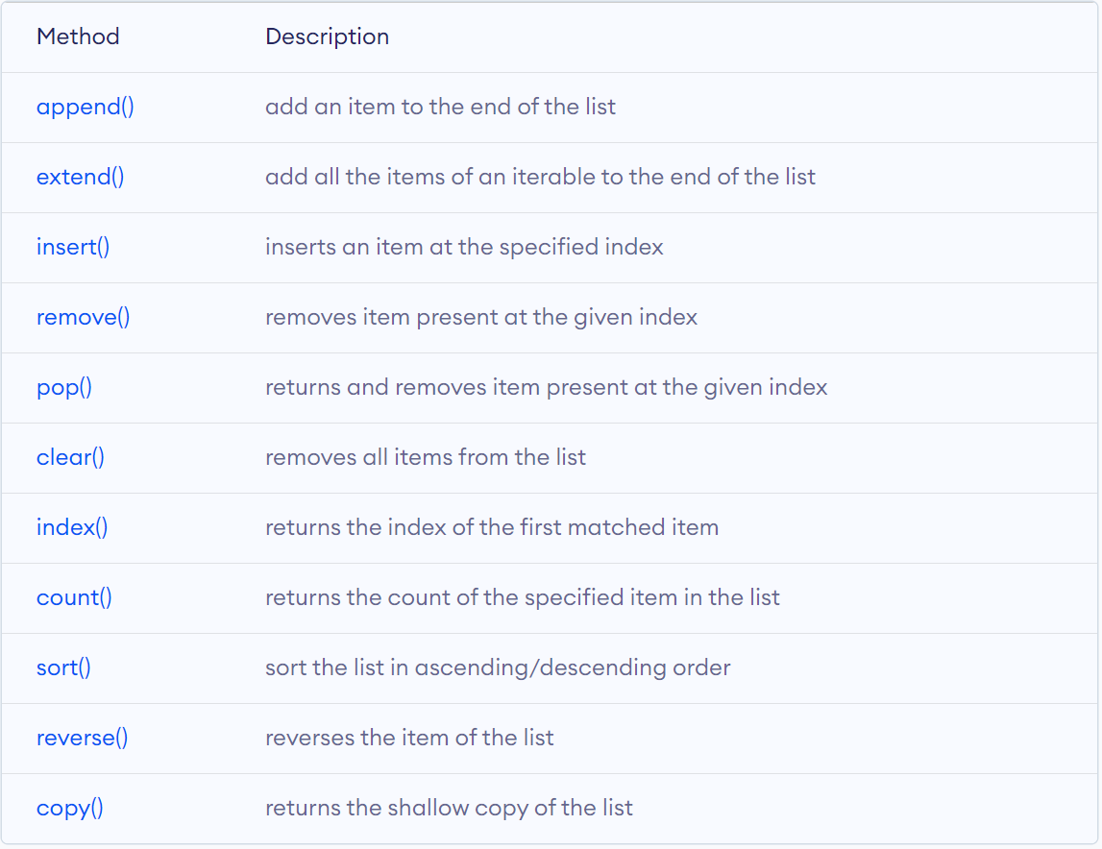
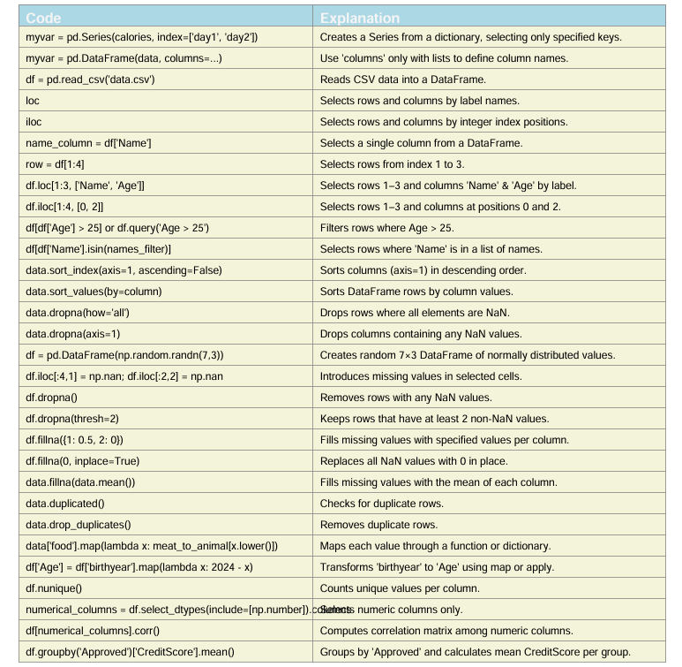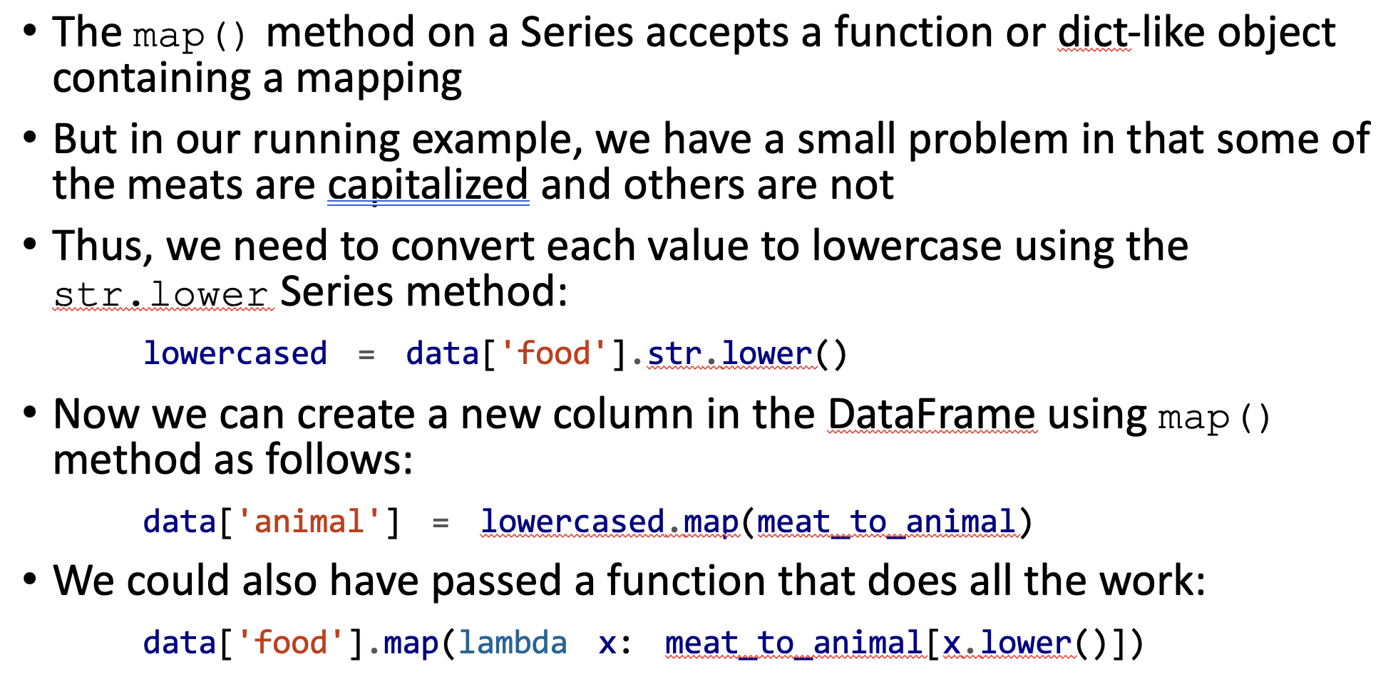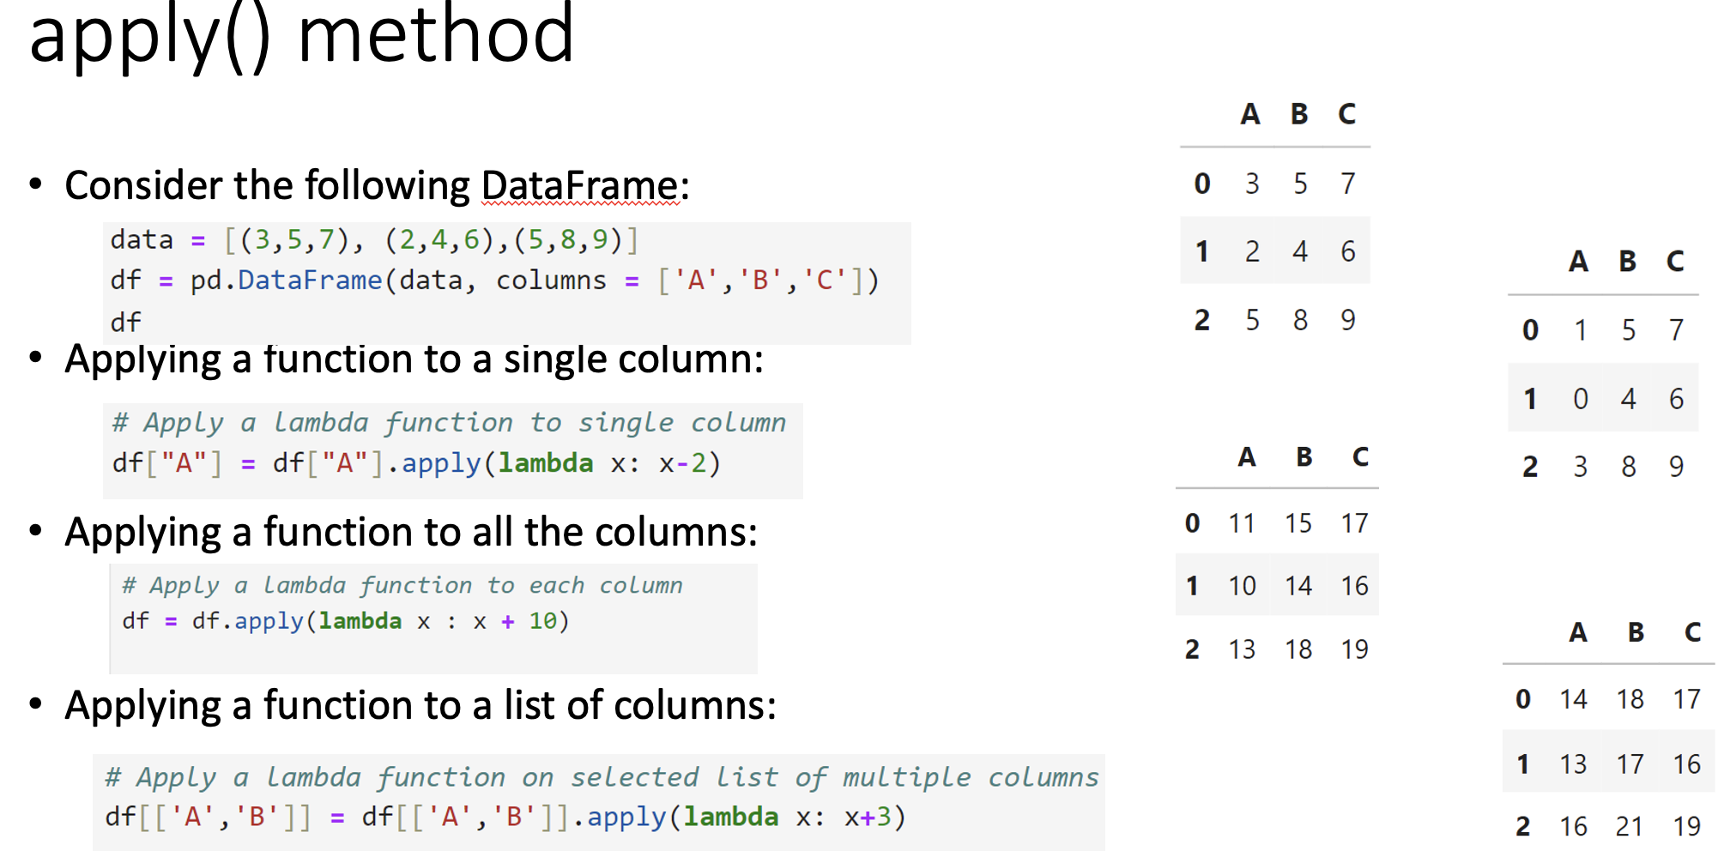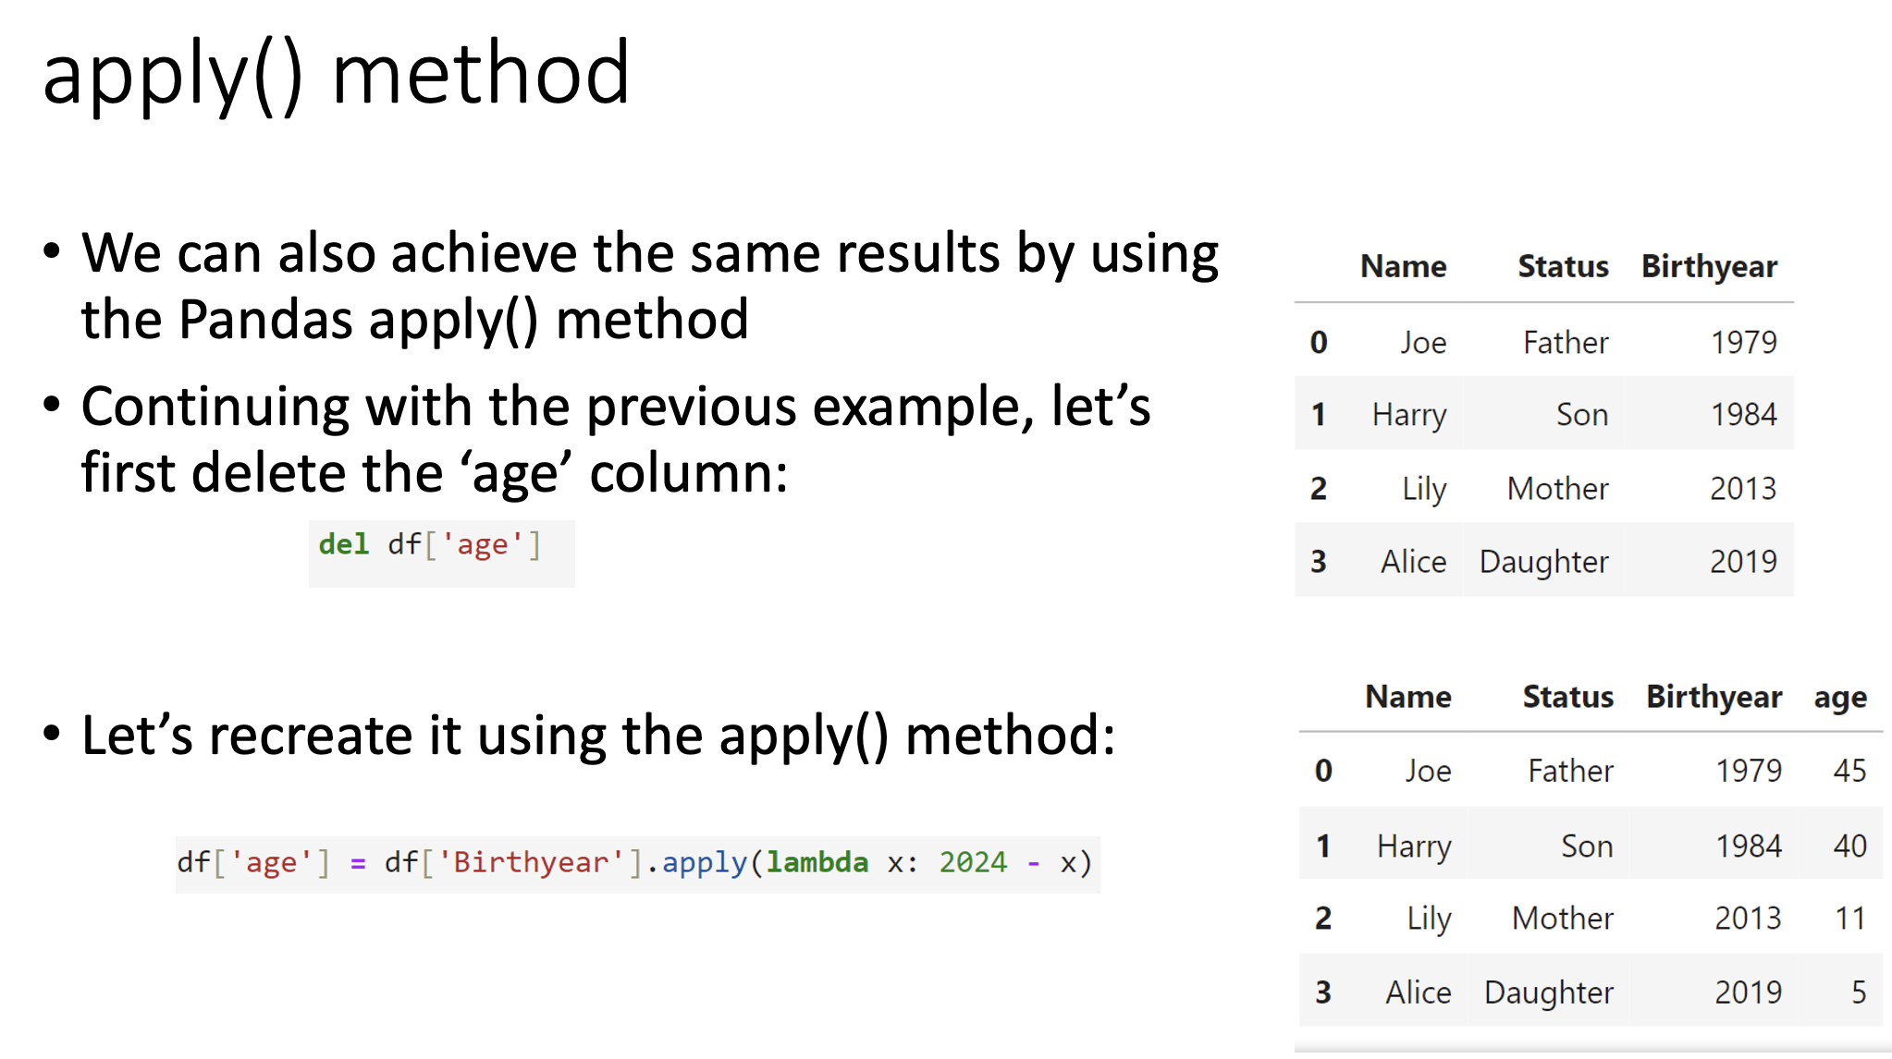
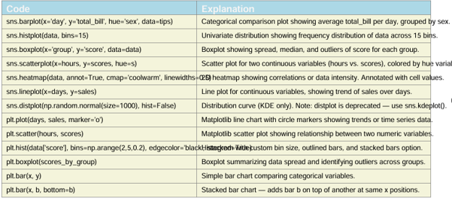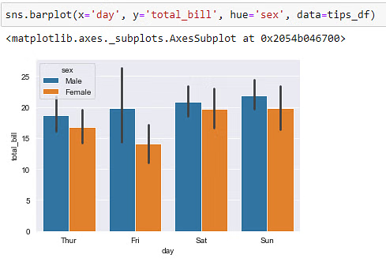
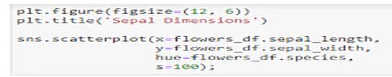

Iterating over keys using keys() method: |  | for key in student.keys(): <br> print(key) | a = "Hello, World!" <br> print(a.upper()) | # returns "HELLO, WORLD!"
Iterating over values using values() method: |  | for val in student.values(): <br> print(val) | print(a.lower()) | # returns “hello, world!"
Iterating over items using items() method: |  | for entry in student.items(): <br> print(entry) | a = " Hello, World! " <br> print(a.strip()) | # returns "Hello, World!"
Iterating over key, value pairs using items() method: |  | for k, v in student.items(): <br> print(f‘key = {k}, value = {v}’) | a = "Hello, World!" | print(a.replace("H", "J")) # returns "Jello, World!"
opening a file, manipulating a file and closing it |  | with open(“output.txt”,”w”) as f: <br> f.write(“Hello Python!”) | a = "Hello, World!" <br> print(a.split(",")) | # returns ['Hello', ' World!’]
Sorting a dictionary using a lambda function |  | sorted(people.items(), key=lambda item: item[1])  #output:[(2, 'Jack'), (4, 'Jane'), (1, 'Jill'), (3, 'Jim')] | myTuple = ("John", "Peter", "Vicky") <br> x = "#".join(myTuple) | John#Peter#Vicky
sort dictionaries using the sorted() function:  people = {3: "Jim", 2: "Jack", 4: "Jane", 1: "Jill"} | # Sort by key: dict(sorted(people.items()))  #output: {1: 'Jill', 2: 'Jack', 3: 'Jim', 4: 'Jane’}  # Sort by value with a user defined function  def get_value(item): <br> return item[1] |  | File Handling: r is read, w write, r+ reading and wiritng, rb+ Reading and writing in binary format, wb writing in binary, w+ write and read, | python<br>with open('filename.txt', 'r') as f:<br> data = f.read()<br>with open('filename.txt', 'w') as f:<br> f.write("Hello Python!")<br>with open('C.txt') as f:<br> for line in f:<br> print(line, end='')<br>

>>> import shelve  >>> shelf_file = shelve.open('mydata’)  >>> shelf_file['cats'] = ['Zophie', 'Pooka', 'Simon’]  >>> shelf_file.close() | >>> shelf_file = shelve.open('mydata’) <br> type(shelf_file)  <class 'shelve.DbfilenameShelf’> #output  >>> shelf_file['cats’]  ['Zophie', 'Pooka', 'Simon’] #output  >>> shelf_file.close() | import os  os.rename(“test.txt”,”Newtest.txt”)  print(“File renamed”) | import os  os.remove(“Newtest.txt”)  print(“File deleted”)
from numpy import random  x = random.randint(100) | x = random.randint(100, size=(5))  x = random.randint(100, size=(3, 5)) | x = random.rand(5)  x = random.rand(3, 5) | x = random.choice([3, 5, 7, 9])  x = random.choice([3, 5, 7, 9], size=(3, 5))
x = random.choice([3, 5, 7, 9], p=[0.1, 0.3, 0.6, 0.0], size=(100)) |  | To sort by multiple columns, pass a list of names:  frame.sort_values(by=['a', 'b'])
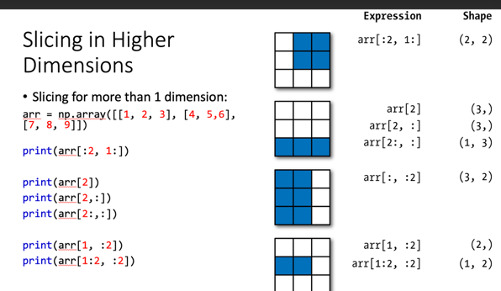
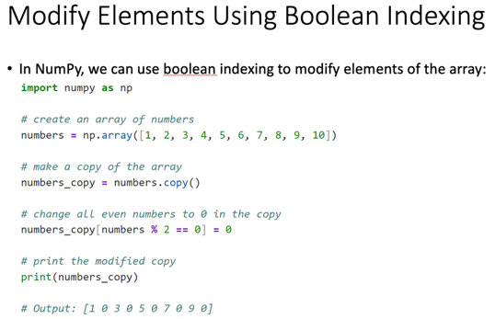
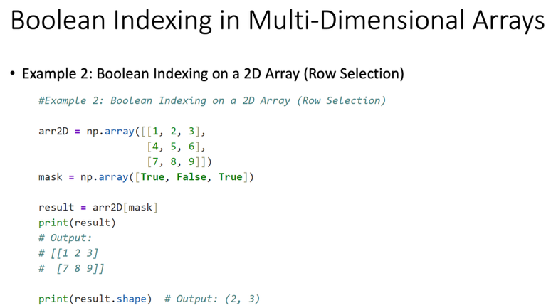

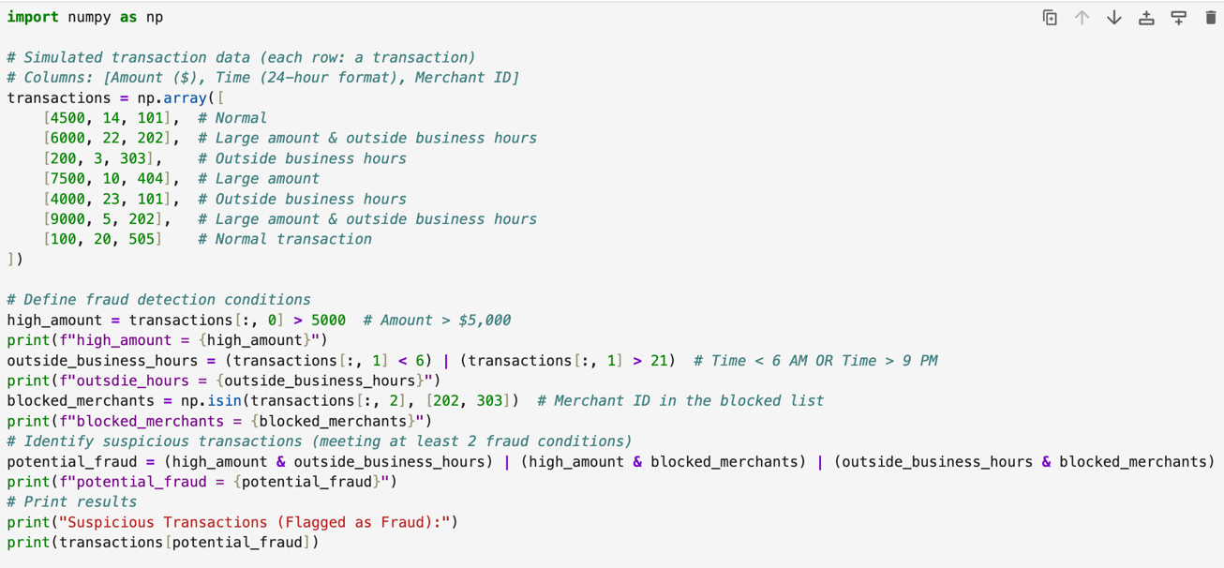

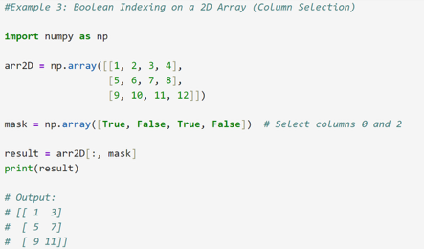

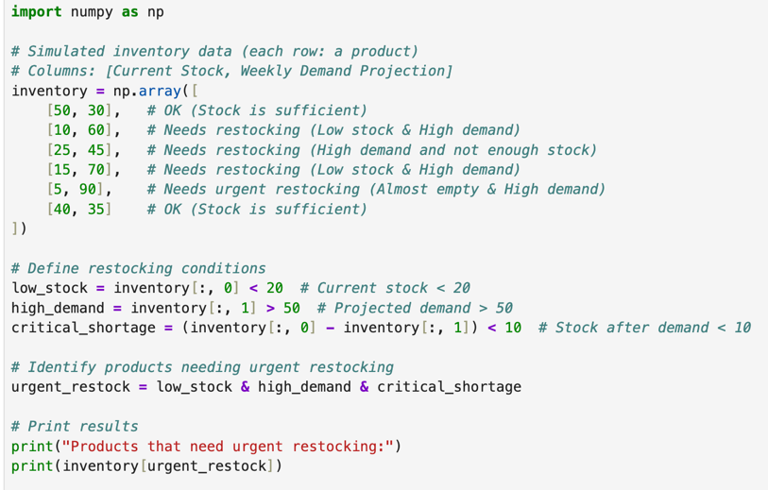

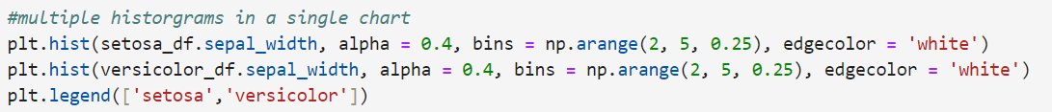
Q1)  Write a Python program that reads a text file named 'quotes.txt' containing famous quotes, each on a separate line. Your program should perform the following tasks:  - Read the 'quotes.txt' file and display the total number of quotes.  - Prompt the user to enter a keyword.  - Search for quotes containing the provided keyword and display those quotes. | Code:  with open('quotes.txt') as f: <br> quotes = [q.strip() for q in f if q.strip()] <br> print("Total quotes:", len(quotes))  keyword = input("Enter keyword: ").lower() <br> print('\n'.join(q for q in quotes if keyword in q.lower()))
Q2)  Question: Matrix Operations  You are working on a project that involves analyzing data represented as matrices. Using NumPy, perform the following tasks:  - Create a NumPy array representing a 3x3 matrix named "matrix_A" with random integer values ranging from 1 to 10.  - Create another NumPy array representing a 3x3 identity matrix named "identity_matrix".  - Perform element-wise multiplication of "matrix_A" and "identity_matrix" and store the result in a new NumPy array named "result_matrix".  - Calculate the sum of all elements in "result_matrix" and print the result.  - Using slice notation, print the 2x2 sub-matrix that includes elements from rows up to and including row # 1 and all columns after and including column 1. | Code:  import numpy as np  matrixA = np.random.randint(1, 11, (3, 3))  identity = np.eye(3, dtype=int)  result = np.multiply(matrixA, identity)  print("Sum of elements:", result.sum())  print("2x2 sub-matrix:\n", result[:2, 1:])
Q3)  You are managing the inventory for an e-commerce platform that sells various products. Your task is to perform analysis on the product inventory dataset to derive insights for better inventory management. You have been provided with a dataset named "inventory_data.csv", which contains the following columns:  - ProductID: Unique identifier for each product.  - ProductName: Name of the product.  - Category: Category of the product (e.g., electronics, clothing, accessories).  - Quantity: Quantity of the product available in the inventory.  - Price: Price of the product per unit.  Your task is to write Python code using Pandas and Numpy to perform the following tasks:  - Load the dataset into a Pandas DataFrame.  - Explore the data and perform any necessary data cleaning or preprocessing.  - Calculate and display the total inventory value for each category (Quantity * Price).  - Identify the top-selling product category based on the total quantity sold.  - Determine the average price of products within each category.  - Analyze the inventory to identify any products that are low in stock (quantity below a certain threshold, e.g., 10 units) and need to be restocked. | Code:  import pandas as pd  df = pd.read_csv('inventorydata.csv')  df['InventoryValue'] = df['Quantity'] * df['Price']  print("Total inventory value per category:\n", df.groupby('Category')['InventoryValue'].sum())  print("Top-selling category:", df.groupby('Category')['Quantity'].sum().idxmax())  print("Average price per category:\n", df.groupby('Category')['Price'].mean())  print("Low stock products:\n", df[df['Quantity'] < 10][['ProductID', 'ProductName', 'Quantity']])
Q4)  You are given a dataset containing the monthly sales performance for three products (product_A, product_B, product_C) across four regions (North, South, East, West) over the past two years. The dataset includes columns: month, region, product_A_sales, product_B_sales, and product_C_sales.  - Using Matplotlib, write Python code to create a line chart showing the monthly sales trends for product_A and product_B in the North region over the two years. Ensure that the axes are labeled, a legend is included, and the individual data points are marked.  - Create a histogram that visualizes the distribution of monthly sales for product_C across all regions. Write the Python code and describe how adjusting the number of bins could change the visualization's interpretation.  - You want to compare sales of all three products across the four regions. Write Python code to create a stacked bar chart that shows the total monthly sales for all products by region.  - Generate a scatter plot that visualizes the relationship between product_A_sales and product_B_sales across all regions. Use color coding to differentiate between regions and explain how this plot can help reveal correlations between the sales of the two products. | Code:  import pandas as pd import matplotlib.pyplot as plt df = pd.read_csv('sales_data.csv') # 1. Line chart (North region)  north = df[df['region'] == 'North'] ax = north.plot(x='month', y=['productA_sales', 'productB_sales'], marker='o')  ax.set_ylabel('Sales'); plt.legend(['A', 'B']); plt.show()  # 2. Histogram (productC sales) df['productC_sales'].plot.hist(bins=10) plt.xlabel('Product C Sales'); plt.show()  # More bins = finer detail; less bins = broader view  # 3. Stacked bar chart (sales by region)  df.groupby('region')[['productA_sales', 'productB_sales', 'productC_sales']].sum().plot.bar(stacked=True)  plt.ylabel('Sales'); plt.show()  # 4. Scatterplot (A vs B sales, by region)  colors = dict(zip(df['region'].unique(), ['r', 'b', 'g', 'm']))  df.plot.scatter(x='productA_sales', y='productB_sales', c=df['region'].map(colors))  plt.legend(colors); plt.show()
Q5)  You are tasked with scraping a list of recent movies along with their release dates, ratings, and genres from a hypothetical webpage containing movie information.  Below is the HTML content of the webpage:  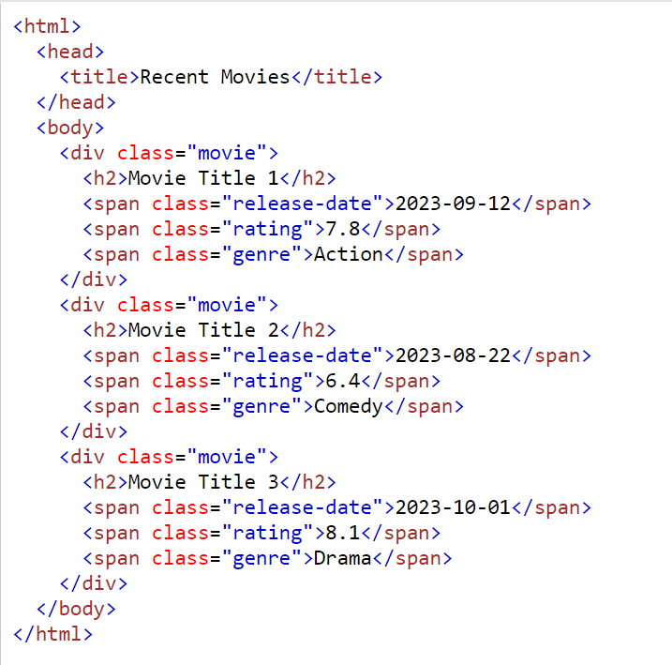  - Write Python code using the requests module to send a GET request to the page. Ensure that you handle potential connection errors.  - Using BeautifulSoup from the bs4 module, parse the HTML content and extract the movie titles, release dates, ratings, and genres. Write Python code to achieve this.  - Organize the extracted data into a Pandas DataFrame with columns: Title, Release Date, Rating, and Genre. Write the Python code to create this DataFrame and display the resulting data.  - Once the data is in the DataFrame, filter out movies with a rating below 7.0. Write Python code to perform this operation and display the filtered DataFrame.  - Finally, save the dataframe to a csv file for later use. | Code:  import requests  from bs4 import BeautifulSoup  import pandas as pd  url = 'http://example.com/movies'  try\: response = requests.get(url, timeout=5) response.raise_for_status()  except Exception as e: print("Error:", e)  soup = BeautifulSoup(response.text, 'html.parser')  rows = [(m.find('span', class_='title').get_text(strip=True),  m.find('span', class_='release_date').get_text(strip=True),  float(m.find('span', class_='rating').get_text(strip=True)),  m.find('span', class_='genre').get_text(strip=True))  for m in soup.select('div.movie')]  df = pd.DataFrame(rows, columns=['Title', 'Release Date', 'Rating', 'Genre'])  print(df[df['Rating'] >= 7.0])  df[df['Rating'] >= 7.0].to_csv('filtered_movies.csv', index=False)  mport numpy as np  # Simulated daily power usage (kWh) for different households (rows: households, cols: days)  daily_power_usage = np.array([  [15, 18, 20, 22, 25, 30, 28], # Household 1  [35, 38, 40, 45, 50, 48, 42], # Household 2  [8, 10, 12, 15, 10, 8, 9], # Household 3  [50, 55, 60, 65, 70, 75, 80] # Household 4 (High user)  ])  # 1. Calculate total monthly consumption (30 days)  monthly_power_usage = np.sum(daily_power_usage, axis=1) * (30 / 7) # Sum over days, scale to 30 days  print("Monthly Power Consumption (kWh):", monthly_power_usage)  # 2. Compute power wastage (assume efficiency threshold of 800 kWh per month)  efficiency_threshold = 800  power_wastage = np.maximum(monthly_power_usage - efficiency_threshold, 0)  print("Power Wastage (kWh):", power_wastage)  # 3. Apply tiered pricing per kWh  standard_rate = 0.12 medium_rate = 0.15 high_rate = 0.20  # Apply pricing logic  low_usage = monthly_power_usage < 500  medium_usage = (monthly_power_usage >= 500) & (monthly_power_usage <= 1000)  high_usage = monthly_power_usage > 1000  # Compute energy bill based on tiered pricing  energy_bill = (monthly_power_usage * standard_rate * low_usage) + \  (monthly_power_usage * medium_rate * medium_usage) + \  (monthly_power_usage * high_rate * high_usage) print("Energy Bills ($):", energy_bill)  # 4. Calculate energy efficiency score using logarithm (lower is better)  efficiency_score = np.log1p(monthly_power_usage) # log(1 + usage) prevents log(0)  print("Energy Efficiency Score:", efficiency_score)

